Comparison Between the Performance of Elastic Search and Oracle

Number of Records in Each Database
 | Oracle | Elastic Search
Number of Records | 883909 | 885049

We start with many records to illustrate the difference in performance.

Operations

Exporting/Importing Records
Both elastic search and oracle took up the same amount of time of export and import which was almost two hours.

Insertion of Records in Database
Note: Time is calculated in seconds.
 | Oracle | Elastic Search
Insertion of One Record | 0.21 | 0.033
Insertion of 2000 rows – without PL/SQL | 2.673 | 0.288
Insertion of 8000 rows – without PL/SQL | 156.898 | 0.419
Insertion of 10000 identical rows – with PL/SQL | 0.558 | 0.553
Insertion of 100000 identical rows – with PL/SQL | ~5 | ~5

We notice that without the use of PL/SQL in oracle, the performance of Elastic Search is significantly better than oracle. With the use of PL/SQL in case of insertion of identical rows, the performance is somewhat close.
However, insertion in general is not a significant issue, what we’re looking for is difference in performance in case of search queries.

Searching through the database

In case of searching with any query in general, Elastic Search shows a great difference. When we try to fetch for example 10000 records, oracle fetches these records in around 20 seconds, but elastic search fetches them in under 300ms, any other latency would be due to the layers the data passes through until it reaches the user, with the added latency elastic search would still be considered faster than oracle.
Example:
 | Oracle | Elastic Search
Number of Records Fetched | 10,150 | 10000
Time Taken | 27.121 Seconds | 274ms

Elastic Search
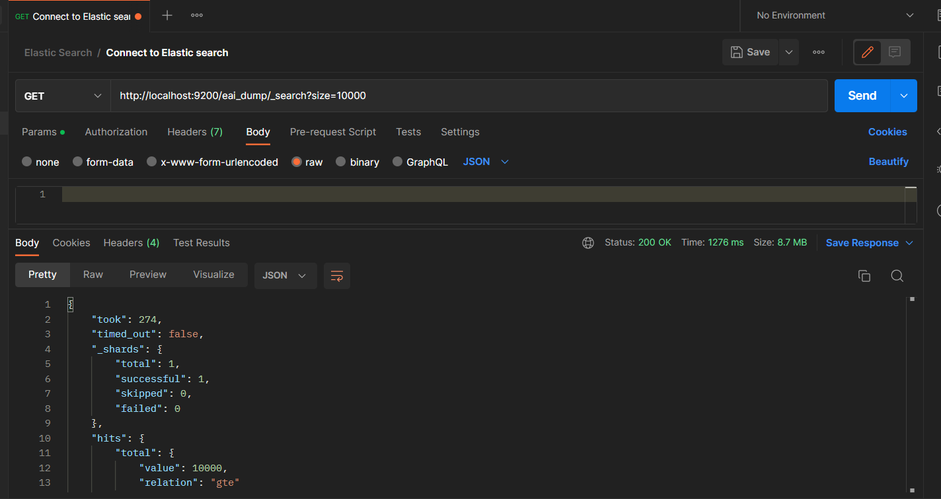
Oracle
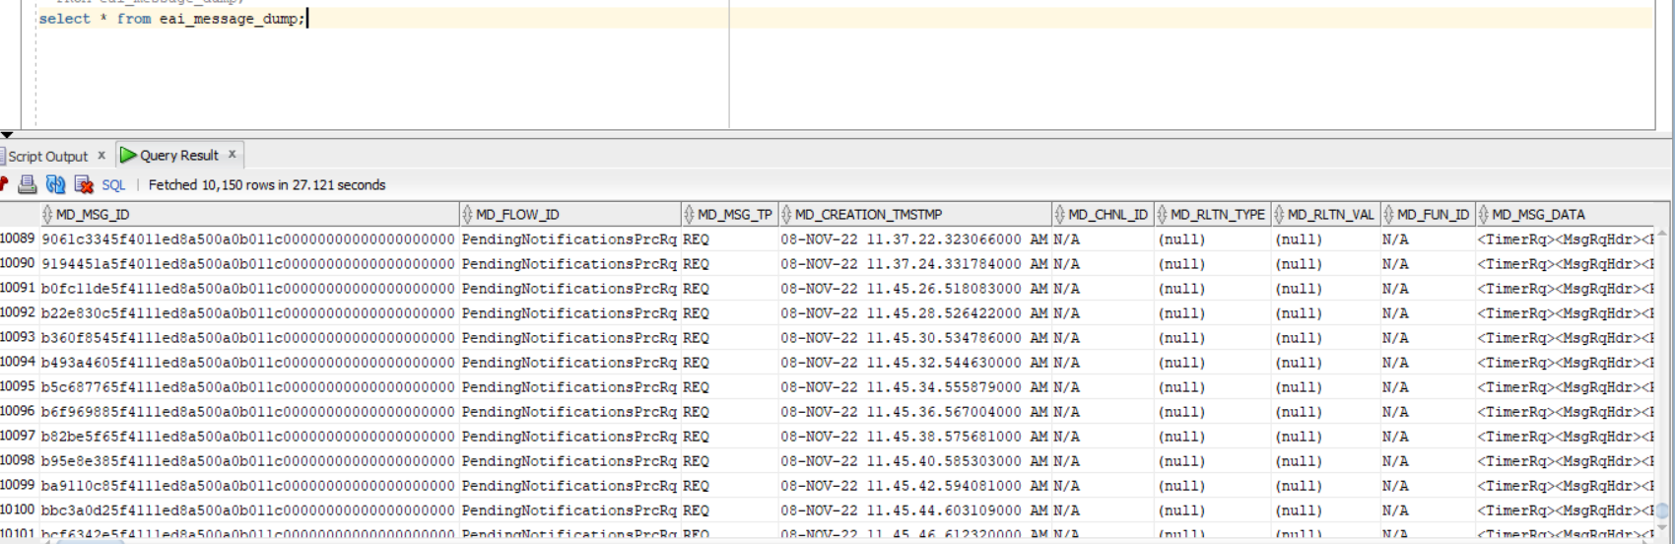
As the number of fetched records increase, the time taken by oracle is still noticeably significantly higher than elastic search.
Furthermore, Elastic search wins in case of full text search as well, which would help us greatly if we were to search the dump message data.

Updating and Deleting Records in Elasticsearch
Updating and deleting are very similar to insertion, the difference in performance is minimal.

